تدريب على اختبار القراءة يوم الثلاثاءالموافق 23/10/2018

G.C : Reading (5Ms. )

CS: A) Group rhyming words or words with the same sound

star- play- shoes- pay- ship- stairs

B)Fill in the sentences with the suitable words from the list:-

television– hair – teeth– dress ))
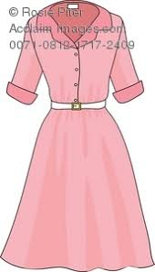
1-Mona has got a red………………..

2-She brushes her………………

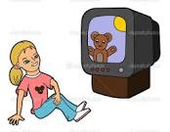
3-I watch………………………

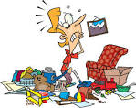
CS: B) Match simple sentences to pictures
1-Tidy your room.

2- I can see a star.
3- The apple is on the desk.

4- I write at five o'clock.

تدريب على اختبار الكتابه الموافق الاربعاء 24/10/2018
الرجاء حفظ قائمه الكلمات المعطاه للطالبه(التى تحتوى على 8 كلمات)
A)Grammar
*Choose the correct answer

1-I pray…………………five o'clock.
a) in b) at c) on

1-It is …………………basket.
a) an b) a c) the
B : Writing

CS: A) Re-order words to make simple sentences with the proper punctuation:
your- brush- hair
5-

…………………………………………………………………………

6-
is- where- the shirt

…………………………………………………………………………………

: B)Complete the sentences with the suitable word:
1-It is a ………………………..

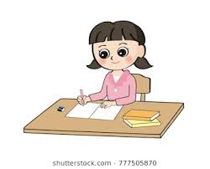
2- I ………………………..my homework.

